Go to the chef folder where you have vagrant file.

C:\Users\mc41946\chef

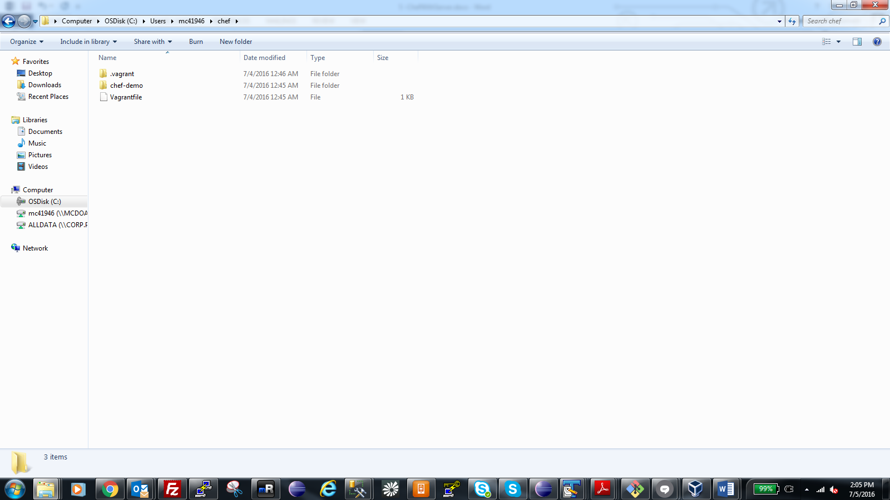

* **Open git bash**
* **$ cd /C/Users/mc41946/chef**
* **Vagrant up (this will open up three connections in Virtual box like this)**

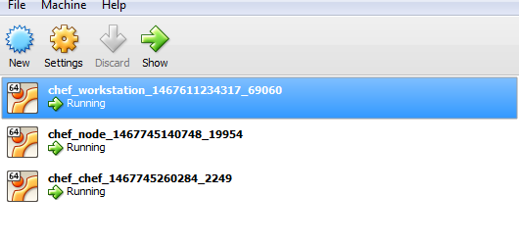

* **Vagran ssh chef**
* **sudo –s**
* cat /vagrant/chef-demo/misc/hosts >> /etc/hosts
* cat /etc/hosts
* ping node (ctrl+c)
* exit
* exit (2 times)
* vagrant ssh node
* sudo –s
* exit
* exit (2 times)
* **Vagran ssh workstation**
* **sudo –s**
* cat /vagrant/chef-demo/misc/hosts >> /etc/hosts
* cat /etc/hosts
* ping **workstation** (ctrl+c)
* exit
* exit (2 times)
* **Vagran ssh chef**
* **sudo –s**
* **cd /home/vagrant**
* **go to** [**https://downloads.chef.io/chef-server/ubuntu/**](https://downloads.chef.io/chef-server/ubuntu/) **and see the server installation url on 64 bit last one.**

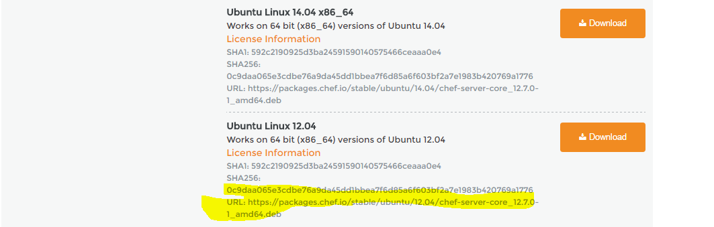

* **wget** <https://packages.chef.io/stable/ubuntu/12.04/chef-server-core_12.7.0-1_amd64.deb>
* **sudo dpkg –i /vagrant/**chef-server-core_12.7.0-1_amd64.deb